**Part 1: Azure Infrastructure Configuration**

**Task 1.1:** Create Resource Groups based on different project environments (e.g. Development, Testing, Production). Explain the organizational benefits of using Resource Groups.

Azure Resource Groups offer a range of benefits, providing a fundamental framework for organizing and managing Azure resources efficiently. Let's dive into a detailed explanation of the key advantages:

1. Resource Organization and Management:
2. Lifecycle Management:
3. Access Control and Security:
4. Resource Tagging:
5. Cost Management:

* **Logical Grouping:**  
  Resource Groups allow you to logically group related resources, making it easier to understand and manage your Azure infrastructure. This simplifies resource organization and reduces the complexity of handling numerous resources.
* **Unified Lifecycle:**  
  Resource Groups enable you to manage the entire lifecycle of related resources collectively. You can create, update, and delete multiple resources at once, simplifying provisioning, maintenance, and deprovisioning.
* **Access Policies:**You can set access policies and permissions at the resource group level, ensuring secure access to all resources within the group. This enhances security by controlling who can modify or view resources.
* **Resource Locks:**Resource Groups support the application of locks to prevent accidental deletion or modification of resources, enhancing data protection and stability.
* **Custom Categorization:**Tagging resources within a group allows for custom categorization based on attributes like environment, department, or project. This simplifies cost allocation, tracking, and reporting.
* **Cost Tracking:**Resource Groups help you monitor and optimize costs. You can track expenses at the resource group level, which aids in budget management and cost control.

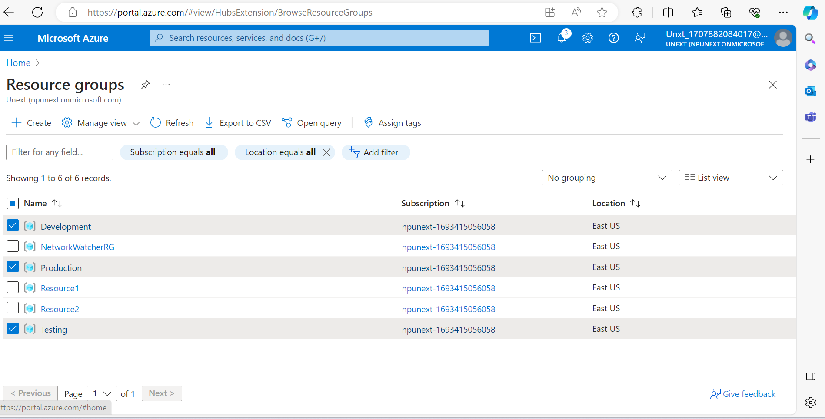

**Task 1.2 :** Explore and document the purpose and usage of Availability Zones and Availability Sets in ensuring application reliability, without creating VMs.

**Availability Zone:**

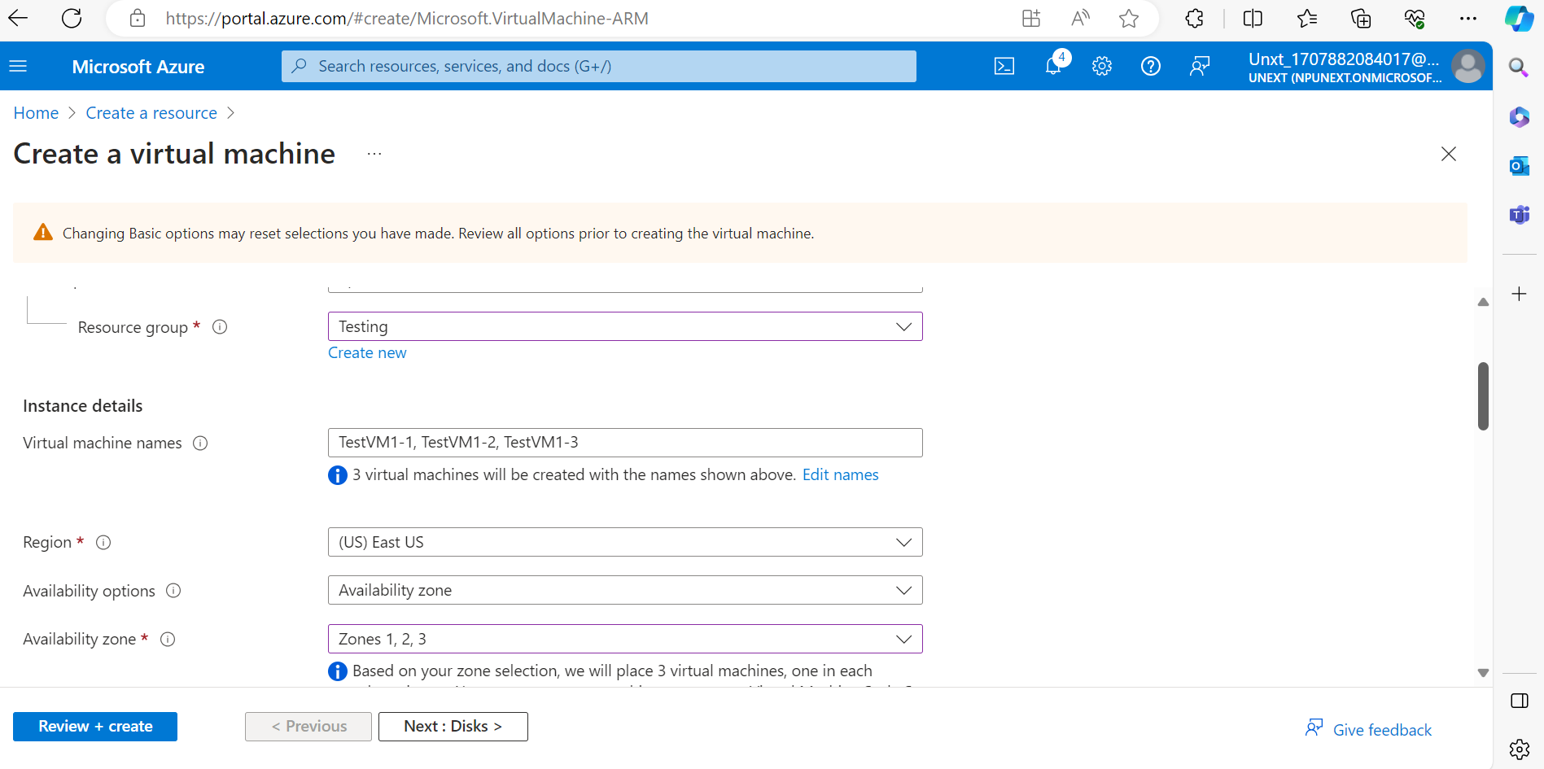

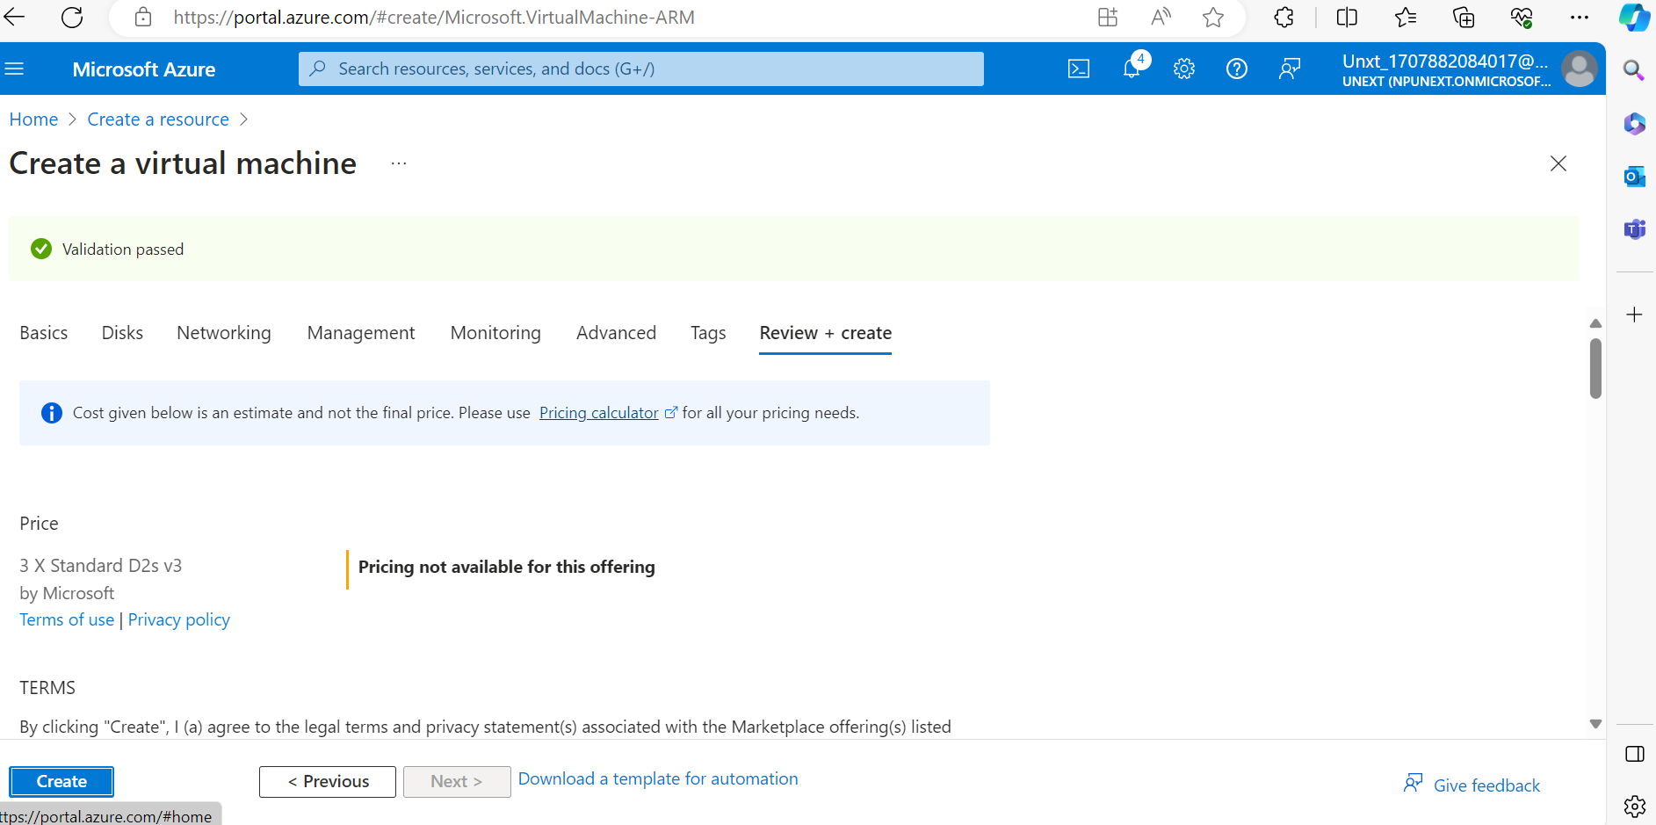

***Purpose:***

1. Availability Zones take reliability to the next level by providing high availability across different datacentres within an Azure region.
2. Each zone consists of one or more datacentres.

***Usage:***

1. Zone-Aware Services:

* When you use availability zones, your workload is spread across different zones within an Azure region.
* An Azure region comprises multiple datacentres, and each zone is composed of one or more datacentres.

***Benefits:***

1. 99.99% SLA: With availability zones, your acceptable downtime per month reduces to less than 5 minutes.
2. Zone Resilience: VMs are distributed across different zones, ensuring resilience even if an entire zone experiences issues.
3. Proximity: VMs in an availability set have improved VM-to-VM latencies compared to availability zones.
4. High Availability: Availability zones minimize single points of failure and offer high availability.

**Availability Set:**

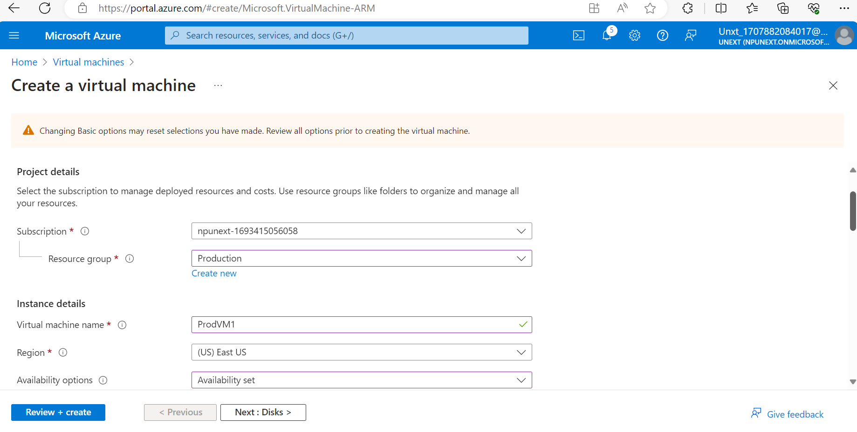

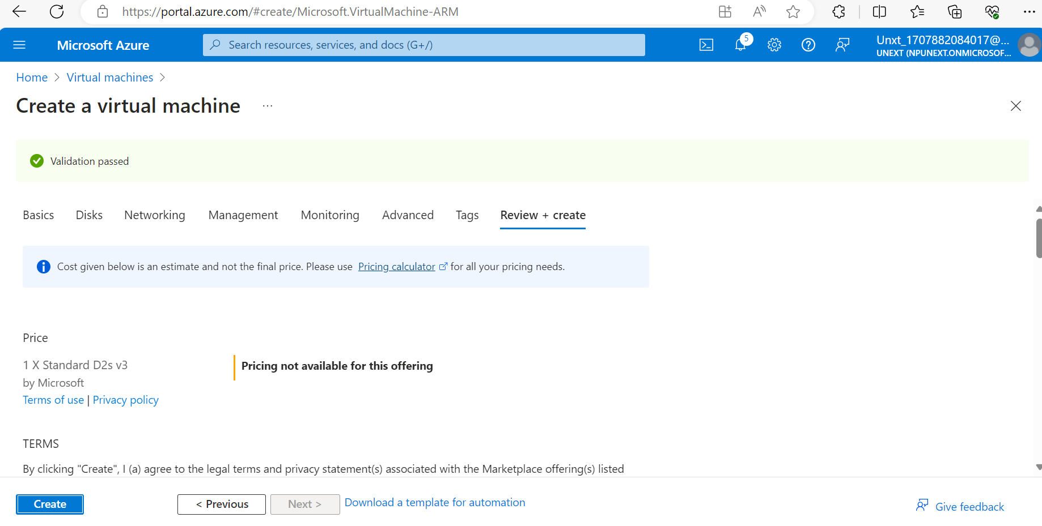

***Purpose:***

a) An Availability Set is a logical grouping of virtual machines (VMs) within an Azure region.

b) It ensures that VMs are distributed across different fault domains and update domains.

***Usage:***

**Fault Domains:**

1. Fault domains represent distinct physical hardware within a datacentre.
2. VMs in the same fault domain share common storage, power sources, and network switches.
3. If one fault domain experiences an issue (e.g., hardware failure), VMs in other fault domains remain unaffected.

**Update Domains:**

1. Update domains group VMs that can be rebooted simultaneously during planned maintenance.
2. VMs in different update domains ensure that not all VMs are updated or rebooted at the same time.

***Benefits:***

1. Improved Availability: By spreading VMs across fault domains and update domains, you reduce the risk of simultaneous failures.
2. Downtime Reduction: Using an availability set decreases acceptable downtime to around 22 minutes per month compared to a single VM deployment.
3. VM Isolation: VMs within an availability set remain isolated from each other.
4. Resource Management: Availability sets apply only to VMs and cannot be used for other Azure resources.
5. Redundancy Planning: Architect your application to fail over to non-impacted VMs for redundancy and business continuity.